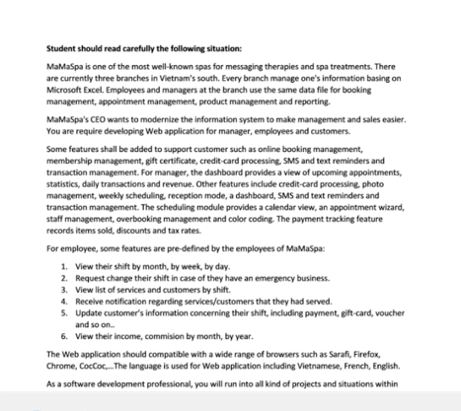

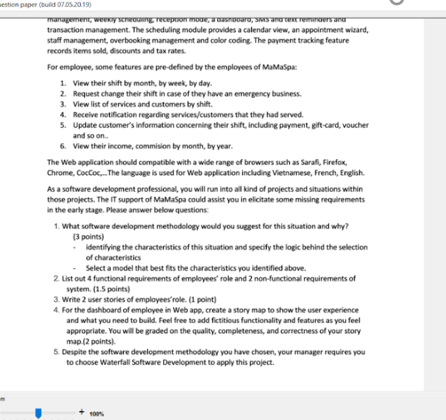

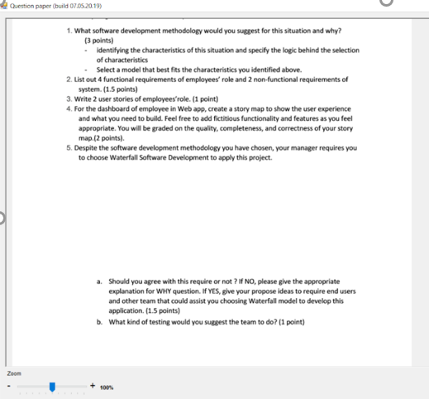

SOLUTION:

1. I will suggest Agile method for this situation. Because:

* Our project is Spa management modernization system, The requirements are clearly defined by MaMaSpa's CEO :

+ Some features shall be added to support customer

+ For manager, the dashboard provides a view of upcoming appointments, statistics, daily transactions and revenue.

+ Many features include credit-card processing, photo management, weekly scheduling, reception mode, a dashboard, …

+ For employee, some features are view their shift, request change their shift, receive notification, Update customer's information….

* The requirements are clearly defined so Waterfall could have some uses here. However, the requirements cannot be fully acquired at the outset of the project for a variety of reasons. Agile models' flexibility allows for rapid shifts in needs. A realistic approach to software development, agile approaches encourage teamwork and cross-training, as well as rapid creation and demonstration of functionality, because it can handle both static and dynamic requirements
* As the aim of this project are manager, employees and customers so lots of feedbacks in the middle of developing the required system are indeed needed to ensure the project is going in the right direction. Again, Agile is good here as Waterfall only allows feedbacks only in the last phase, after the software is completely done and no changes could be made.
* In light of the foregoing evaluation, I feel that the Agile model is the most appropriate approach in this situation due to the frequent supply of requirements. Since the requirements system is flexible and subject to change at any time, it is appropriate to deploy the system first rather than developing it in stages.

2.

* List 4 functional requirements of employees' role:

- For employee, they are view their shift by month, by week, by day.

- Employee can request change their shift in case of they have an emergency business.

- Employee should be receive notification regarding services/customers that they had served.

- Employee can update customer's information concerning their shift, including payment, gift-card, voucher and so on..

* List 2 non-functional requirements of system:
* The Web application should compatible with a wide range of browsers such as Sarafi, Firefox, Chrome, CocCoc,..
* The language is used for Web application including Vietnamese, French, English.

3. 2 user stories of employees 'role:

- As a employee, I want to view my shift by month, by week, by day, such that organize and manage time effectively

- As a employee, I want to update customer's information concerning my shift, including payment, gift-card, voucher, such that know and serve customers better.

4. For the dashboard of employee in Web app, create a story map to show the user experience:

Activities

Managing the user experience

Online booking management

User Management

Task

Cancel experience

Update Preferences

Login

Register

Change experience

Add,View experience

View room info

Book Room

Search for room

By Username

Change date

Credit Card

By Room Type

Show pictures

Create form login

Create new User

Change room

By Location

View Room Details

By Availability

Update Name & Email

Gift certificate

Upload Profile Image

Google Account Login

Facebook Login

Language including Vietnamese, French, English.

Language including Vietnamese, French, English.

5.

a. My manager requires me to choose Waterfall Software Development to apply this project.

I don’t agree with this require. Because:

The benefit of agile over waterfall is the ability to change dynamically to the customer's wants and needs. A focus on the features that are the highest value to the customer. A short-fixed timeline that allows for immediate feedback from the customer and the ability to move deliverables into production. So our new service could be stable, secure, and ease to use. This also assures the loss of younger customers to much quality and customer service is the key. Agile works well with small dedicated team members and lets the team load balance workloads.

b. I suggest the team to Automation testing